Oleynik Vladislav ИПЗ-2.02.01

Exercise 1

1)

#include <iostream>

using namespace std;

void myFunction_1()

{

cout << "Three blind mice\n";

}

void myFunction_2()

{

cout << "See how they run\n";

}

int main()

{

myFunction_1();

myFunction_1();

myFunction_2();

myFunction_2();

return 0;

}

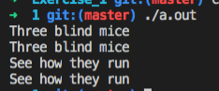

2)

#include <iostream>

using namespace std;

int main()

{

cout << "Enter your age:" << endl;

int age = 0;

cin >> age;

cout << "Your age in months is " << age * 12 << endl;

return 0;

}

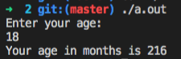

3)

#include <iostream>

using namespace std;

int translateValue(int val)

{

return val * 1.8 + 32;

}

int main()

{

cout << "val: " << translateValue(20) << endl;

return 0;

}



4) #include <iostream>

using namespace std;

void time(int hours, int minutes) {

cout << "Time: " << hours << ':' << minutes << endl;

}

int main()

{

time(10,34);

return 0;

}

